**Optimizing Waste Management with IoT: Boosting Efficiency and Promoting Sustainability**

**Md. Rashed1, Shoaib Ahmad2 , Md Shakil Hossain3**

Dept. of Information and Communication Engineering,

Pubna University of Science and Technology, Pabna sadar , Pabna, Bangladesh.

---------------------------------------------------------------------***---------------------------------------------------------------------

**Abstract -** This paper proposes an Internet of Things (IoT)-based smart trash cans observing the system, which can detect the current trash receptivity. Waste is produced by both individuals and businesses, but how it is disposed of needs to be managed to protect the environment and public health. Implementing effective waste management systems is essential to the development of sustainable and livable cities. Recycling is a useful waste management tactic in this case that can be used. waste monitoring and disposal are handled by people in the current traditional system, which is laborious. By integrating IoT into the traditional system, waste bin monitoring will become simpler. The aim of this study is to explore the Internet of Things and provide an architecture for a Smart Waste Management System in a smart city that is based on IoT. In order to address scalability and adaptation issues, we aim to illustrate how IoT may be used to handle and manage garbage in smart cities. The suggested method uses ultrasonic sensors to convey the waste's status to the bin and determine its volume of trash. Through the use of the worldwide system for mobile (GSM), the server will send an SMS to the relevant parties (the waste collection vehicle's driver). These smart trash cans have been designed by using ARDUINO UNO with ultrasonic sensors, servo motors,LCD display, Blynk app and battery jumper cables. There all hardware and software connections have already been completed and the smart trash clean-up program has been driven properly. The trash can cover waits for the user to put down the garbage can and when someone goes away from it then it will be closed. From an environmental point of view, it contributes to green and hygiene, from a business point of view, we try to originate it reasonably for as most of people as possible.

***Key Words*:** Internet of Things (IoT), Smart Trash Can, Ultrasonic Sensors,GSM, Smart Waste Management System.

**1. INTRODUCTION**

In the pursuit of a healthy and captivating environment, cities across the globe are embracing innovative technologies to enhance their aesthetics and quality of life. As our world rapidly urbanizes, the need for sustainable solutions to address environmental challenges becomes more pressing. One of the most extensive issues faced by modern cities is the accumulation of dust, which not only mars the beauty of the cityscape but also poses significant health risks to its inhabitants. Solid waste management is a large challenge for the environment in smart areas across the universe[1]. On the streets of urban cities, hundreds of people are passing the same location for around one minute[6]. Around 95% of people are carrying food covers, polythene bags, and plastic bottles. If they dispose of all of them at once, the bins will be filled in several minutes. In order, to maintain a beautiful and healthy green environment, there is a need for an efficient waste management solution. The solution will include all the activities essential for monitoring the waste from its inner level outside the garbage bin to the collection of garbage. In paper [11] the main aim of this text is to give an image of the Web of Things and its edges, even associated with the sector of energy. System [12] proposed a university has its special atmosphere of waste, particularly the specific classes of waste and also the unnatural production of waste at a special time. According to the system [9] Smart Cities are being designed and designed for comfortable human residency. Among courtesies that good Cities can deliver is the environmentally friendly waste assortment and process. During this paper, we have a preference to inspire and propose an Internet of Things (IoT) allowed system design to achieve dynamic waste assortment. According to the system [10] Collecting urban knowledge on an incredibly citywide scale plays a primary role in the analysis, development, and implementation of smart cities. This demo presents Cruisers, an associate automotive sensing platform for smart cities. In [13-16], researchers assume capacity, weight, temperature, humidity, and chemical sensors for solid garbage collection. Specifically, in [13], the authors propose a municipal solid waste platform exploiting recycling collection information based on IoT Technology. The paper displays a model for waste collection, transportation, and reusing. In [19] authors have considered two garbage bins, for waste segregation, and detectors are connected to bins for waste data collection to avoid overfilling. The proposed system [18] uses ultrasonic sensors to collect real-time waste levels which take the waste readings every time the lid of the bin is opened and closed. The paper [22] focuses on the real-time garbage level and the level of toxicity attending in it and uses the air quality sensor CCS811 for measuring the toxicity level. The routes are generated using Dijkstra’s algorithm. The system of [17] uses real-time waste data and calculates the shortest path using Google API. The elementary components of IoT are accompanied by Intelligent Transportation Systems and surveillance systems which improve the Quality of Service in garbage collection. It has proposed an advanced Decision Support System model in the paper [21]. In the system of [20] Waste collection routing problem is included in a mixed-integer nonlinear programming model after which waste is unloaded to find out the optimal route for all the garbage trucks. An Android app is implemented in order for the drivers to have a user-friendly GUI interface with the IOT system [25]. A city service that acts as a countermeasure to environmental pollution within the Smart City is IoT-enabled garbage collection. Related research in the literature addresses the treatment of waste collection as an essential municipal service [24], [23].In recent times followed mechanisms include the garbage collector departing through particular dust bin zones and checking for waste. The trash vans/trucks follow a denotes path for collecting the trash from bins. This traditional process of identification, monitoring, and collection of trash is complex, difficult, and involves a lot of manual effort and cost. About 5,000 tonnes of waste is being generated in Dhaka city every day. Only half of that amount is properly collected and dumped, while the other half remains untreated. More than 2.01 billion tonnes of waste are produced globally, maybe a third is not even maintained in a hygienic safe manner[3]. Hence it is necessary to manage these wastes quickly and efficiently. It has become the need of the hour to overcome this situation by taking proper decisions and crucial actions. A garbage collection management system can prove beneficial to obstacle the issue of the extensive rise in waste over the period. Researchers are deeply trying to respond to a cost-effective method for waste management in different countries. Some of the mechanisms are already in practice as per allocated by the respective authorities. Majority of the countries stick to a curbside disposal mechanism where garbage is collected over definite periodic intervals by garbage collection trucks and is dumped at the disposal yards [3].

In response to this challenge, we present a groundbreaking conference paper that introduces an IoT-based innovative dust-cleaning system. IoT-based technologies play an important role in smart cities for the implementation of new services and redesigning existing services [4]. The new point of view of global IoT infrastructures gives us the possibility to collect data and, further, deal with common management issues more effectively[5]. According to the system [8] the Internet of Things (IoT), obviously infrastructure for the imagined idea of a good town, brings new potentialities for town management. The core principle of this system lies in harnessing the power of the Internet of Things(IoT) technology to automate and optimize the dust-cleaning process, thus offering a unique and comprehensive approach to transforming cities into breathtaking beautiful urban havens.

Our IoT-based trash cans help people dispose of their waste It’s easy and helps reduce phone calls and waiting for work Designated area cleaners and a healthier environment to live in, you are nothing. Diseases and people become healthier and less vulnerable to Diseases caused by these waste products. This system Ensures trash cans are cleaned as soon as they reach the trash level reach the maximum. It takes over power with the help of a battery. If you don’t clean the trash can within a certain amount of time, For appropriate action to be taken, recordings might be transmitted to a sweeper or higher authority for affected contractors. Finally, keeping the environment clean and Waste management becomes much easier.

This innovative design is adaptable to various waste types and urban settings, enhancing the efficiency of waste collection by providing real-time data, reducing unnecessary collection trips, and lowering operational costs and environmental impact. By preventing overflows and ensuring timely waste collection, the system contributes to cleaner urban environments, promotes sustainable practices, and enhances public awareness and engagement in maintaining cleanliness and hygiene. This integration of smart technology into waste management systems demonstrates substantial improvements in operational efficiency and sustainability.

* 1. **Review of Related Work**

Sagar Chavan, Umesh Patil, Santosh Sam Koshy, S.V. Srikanth [1] proposed an IoT based system for smart waste management. the primary contribution of that work is its focus on achieving low cost, low power consumption, and long battery life in the hardware and software architecture. However, limitations include potential challenges in scalability for larger urban areas, the dependency on reliable network infrastructure, and the need for continuous maintenance of sensor modules to ensure accuracy and functionality.

The system proposed in the paper[3] system offers significant contributions to waste management by utilizing ultrasonic sensors to gather real-time data on garbage levels. This data facilitates the generation of dynamic routes for garbage trucks, enhancing route efficiency, optimizing truck capacity, and minimizing fuel consumption.The limitations include the initial cost of sensor installation, potential maintenance challenges, and the need for reliable network connectivity to ensure real-time data transmission. Additionally, the system's efficiency may be affected by varying bin types and environmental conditions.

Smart cities integrate multiple ICT and IoT solutions to build a comfortable human habitation. One of this solution [25] is to provide an environmentally friendly, efficient and effective garbage management system. The current garbage collection system includes routine garbage trucks doing rounds daily or weekly, which not only doesn't cover every zone of the city but is a completely inefficient use of government resources. This paper proposes a cost-effective IoT based system for the government to utilize available resources to efficiently manage the overwhelming amounts of garbage collected each day, while also providing a better solution for the inconvenience of garbage disposal for the citizens.

This paper [19] proposes an IoT-based approach for garbage monitoring and disposal, leveraging ultrasonic and MQ4 sensors. Ultrasonic sensors monitor the fill level of both biodegradable and non-biodegradable "smart bins," while MQ4 sensors assess the odour level in biodegradable bins. Once the threshold level is reached in the non-biodegradable bin, the system alerts the municipal corporation via a dedicated application for timely disposalbut it lacks discussion on the scalability and feasibility of implementing such a system across diverse urban landscapes in India.

Authors of paper [5] focused on an IoT-based approach for garbage monitoring and disposal offers innovative solutions to India's waste management challenges. However, it exhibits several limitations that must be acknowledged. Firstly, there is a lack of discussion on the scalability of the system across diverse urban landscapes in India, which is crucial for its widespread adoption and effectiveness.

The paper [2] introduces a system aimed at efficiently managing waste in large cities, eliminating the need for continuous manual monitoring. The problem of disorganized and non-systematic waste collection is addressed through the design of an embedded IoT system, capable of monitoring individual dumpsters for waste deposition.

The idea proposed in the paper [7] automatic garbage segregator system presents innovative solutions for household waste management, its implementation may face challenges including complexity and cost, sensor accuracy issues, maintenance requirements, limited waste types, scalability concerns, user acceptance barriers, and potential environmental impacts.

Table 1: List of the papers reviewed

|  |  |  |
| --- | --- | --- |
| TITLE | CONTRIBUTION | ANALYSIS |
| Garbage Zero (Garb0): An IoT Framework for Effective Garbage Management in Smart Cities [1] | Utilizing low-cost, low-power LoRa technology, Garb0 provides fill level data for outdoor garbage bins, optimizing waste collection routes and schedules to enhance urban cleanliness and efficiency. | Effectively prevents overfilling of garbage bins through real-time monitoring, but it currently lacks a mechanism for automated waste collection. |
| Garbage Collection System using IoT for Smart City [3] | Utilizing ultrasonic sensors, the system gathers real-time garbage levels and generates dynamic routes for garbage trucks, improving efficiency, reducing fuel consumption, and promoting a cleaner environment. | prevention of overfilling bins highlights its effectiveness, but the absence of real-time garbage level monitoring underscores the disorderly collection |
| Location Based Garbage Management System with IoT for Smart City. [25] | The system uses a network of smart bins and cloud-based data analysis to generate predictive routes for garbage trucks. An Android app supports the workforce with route information and helps citizens locate the nearest available smart bin. | relying on routine truck rounds conducted daily or weekly, fails to cover every city zone. |
| Garbage Monitoring and Disposal System for Smart City Using Iot. [19] | The system utilizes ultrasonic and MQ4 sensors to monitor garbage levels and odor in smart bins. When thresholds are exceeded, data is sent to the municipal corporation for disposal. | intricacies of garbage monitoring and disposal, it falls short in addressing the critical aspects of scalability and feasibility |
| IoT based Waste Collection Management System for Smart Cities: An Overview.[5] | To address the issue of overflowing dustbins in public places like hospitals, educational institutes, and industries. The system utilizes Raspberry Pi Uno board interfaced with GSM modem, ultrasonic sensor, and weight sensor to monitor dustbin levels and weight. | Innovative solutions to India's waste management challenges, this approach lacks adequate exploration of feasibility concerns, including cost-effectiveness, infrastructure requirements. |
| Smart Dustbin Monitoring System using Arduino  UNO. [2] | Segregating dry and wet waste and monitoring waste levels, the system aims to improve cleanliness in society and reduce the spread of diseases caused by waste materials. | Efficiently managing waste in large cities, eliminating the need for continuous manual monitoring, but disorganized and non-systematic waste collection is addressed. |
| Smart Waste Management System Based On The Internet Of Things. [7] | The system employs ultrasonic and metallic sensors to detect and separate waste into dry, wet, and metallic categories. Capacitive detectors further assist in waste division | Real-time monitoring of rubbish levels and facilitating waste segregation, this system may encounter challenges such as complexity and cost, sensor accuracy issues |

* 1. **Hardware Components**

The hardware components required are **A**rduino Mega 2560, **L**CD Display, **B**in, **X**HM711, **L**oad Sensor, **N**odeMCU, **G**PS, **G**SM, **S**ervo Motor, **T**wo Sonar, **L**ED Bulb, **S**MPS 12v 2A, **B**uck converter **2** pin plug wire.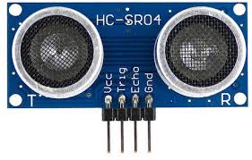

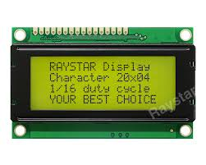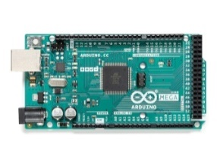



Arduino Mega 2560 LCD Display Ultrasonic Sensor

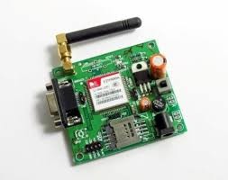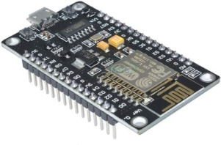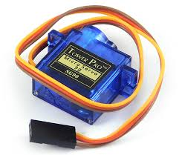

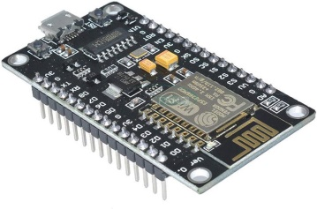

Servo Motor GSM Module NodeMCU

Arduino Mega 2560:

The Arduino Mega 2560 is a microcontroller board based on the ATmega2560. It has 54 digital input/output pins (of which 15 can be used as PWM outputs), 16 analog inputs, 4 UARTs (hardware serial ports), a 16 MHz crystal oscillator, a USB connection, a power jack, an ICSP header, and a reset button. It contains everything needed to support the microcontroller; simply connect it to a computer with a USB cable or power it with a AC-to-DC adapter or battery to get started. The Mega 2560 board is compatible with most shields designed for the Uno and the former boards Duemilanove or Diecimila.

NodeMCU:

An IoT-based platform is called NodeMCU. This is how Wi-Fi is made to function. This board has hardware based on the ESP-12 module and firmware operating on the ESP8266 Wi-Fi SoC Express system. This card has a second coin code programmed into it and is attached to another ultrasonic sensor. The appropriate board needs to be chosen in the Arduino IDE before any code is rendered. Many open-source programs, like Luacjson and SPIFFS, are used in this.

Ultrasonic Sensor:

The ultrasonic sensor is hardware that measures distance using ultrasonic sound waves. This sensor has a transducer that sends and receives ultrasonic pulses based on the proximity of an object. The ultrasonic sensor detects objects and waste. The integrated circuit in the module calculates the time it takes for the ultrasonic wave to return and activates the high echo pin at the same time, allowing us to determine how long it takes.

Servo Motor:

A servo motor helps to open the trash can lid. The Arduino is programmed so that after the ultrasonic sensor detects the trash, the lid opens automatically using the servo motor.

GSM Module:

The GSM module is used to establish communication between a computer and the GPRS GSM system. The Global System for Mobility (GSM) is an architecture used for mobile communications in most countries. Global Packet Radio Service (GPRS) is an extension of GSM that allows higher data rates. The GSM/GPRS module consists of a GSM/GPRS modem assembled with a power circuit and communication interfaces (such as RS-232, USB, etc.) to the computer. A GSM/GPRS modem is a type of wireless modem designed for computer communication with GSM and GPRS networks. It requires a SIM (Subscriber Identity Module) card like a mobile phone to communicate with the network. Additionally, they have an IMEI (International Mobile Equipment Identity) number for identification. A GSM modem is a wireless modem that works with GSM wireless networks, similar to how a dial-up modem works with landline phone lines, but instead sends and receives data through radio waves. The GSM modem can be an external device or integrated into a PC. Like GSM cell phones, GSM modems require a SIM card from a wireless service provider to function.

## 2. Proposed Methodology

The proposed method involves monitoring and collecting solid dust from wet and dry garbage bins placed at different places in a particular area. The proposed system is implemented by considering the following:

The ultrasonic sensor is located on the front panel which has four pins labeled Vcc, GND, ECHO, and TRIG. The TRIG and ECHO pins are connected to digital pins two and three on the Arduino board. The servo motor has three pins named Vcc, GND, and the servo pin. The servo pin of the servo motor is connected to PIN nine on the Arduino board. Once the connections are made, the Arduino is plugged into the system, and using the Arduino IDE, the code is injected inside the Arduino. This ends the connection and returns the code for the first part. The code for this project is divided into two parts. The header code indicates the operation of the recycle bin, i.e. mainly the operation of opening the lid of the trash can. The second part code indicates the portion of the message received on the mobile device using the Blynk app. The second part is structured as follows:

The ultrasonic sensor placed inside the tank also has the same four pins named Vcc, GND, ECHO, and TRIG. In Arduino IDE, the board should be changed from Arduino UNO to NodeMCU, if the board is not on the list, we need to install the board from the board manager. In this section, the TRIG and ECHO pins of the ultrasonic sensor are connected to the digital pins D5 and D6 of the NodeMCU. Vcc is connected to the Vin of NodeMCU and GND to the ground of NodeMCU. This requires login and now the code needs to be injected into the NodeMCU. Connect the Arduino’s RX pin to the GSM module’s TX pin and the Arduino’s TX pin to the GSM module’s RX pin. Connect the Arduino’s GND to the module’s ground. In addition, the GSM module needs an external 12v power supply.

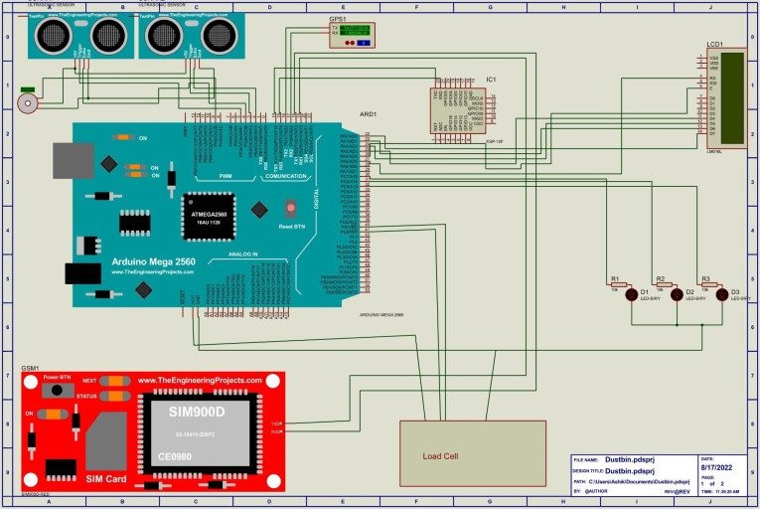

**Fig-1**: Circuit diagram of the proposed method

For developing a smart dustbin we need software and coding with hardware. Here, we implement hardware and attached their images, and also give the source code link which is built in C language.

We test the project in two phases: software and hardware. The hardware part should be physically tested, while the software part is meant to be tested via the Arduino IDE. I need to verify if the system is working properly. Check the distance indicated by the sensor to make sure the reading is correct. Put the trash in front of the ultrasonic sensor first, or the sensor will detect the trash and close the lid of the trash can Open and throw the trash in the trash can. This process repeats and continues like a cycle.

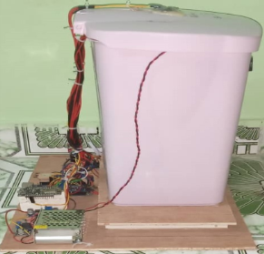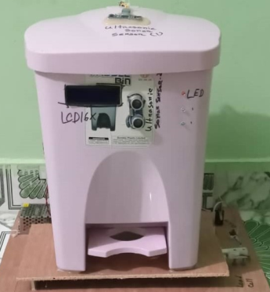

**Fig-2**: Front Part of Dustbin **Fig- 3**: Left Part of Dustbin

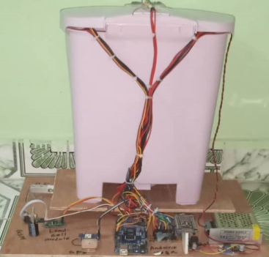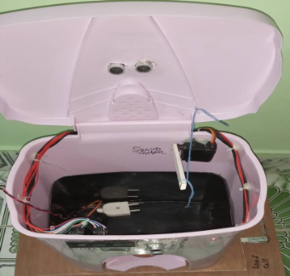

**Fig-4**: Inside Part of Dustbin **Fig- 5**: Back Part of Dustbin

To verify the project, Arduino IDE is essential for testing the required Arduino program software. This enables a thorough examination of program functionality. Hardware testing necessitates a power supply, alongside a tape measure for appropriate range measurement. It's imperative to note that landfills are designated solely for solid waste disposal. The Nodemcu must establish a connection with the Blynk app, and subsequently, the app should showcase the output. To achieve this, the NodeMCU must initially establish a connection with a WiFi hotspot. Testing procedure as follows:

Step 1: At first connect the circuit perfectly according to the proposed method.

Step 2: Turn the system on.

Step 3: Change the loss level so that the ultrasonic sensor provides the output.

Step 4: After getting output it will send a message via the GSM module

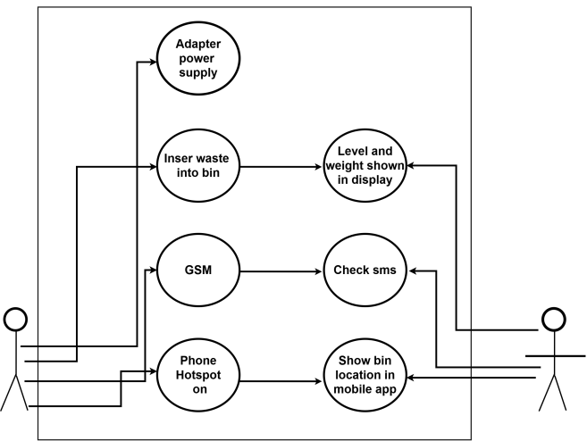

**Fig-6**: Use case diagram of proposed method

2.1 Result and Discussion

The hardware part should be physically tested, while the software part is desired to be tested via the Arduino IDE. I need to verify if the system is working correctly. Check the distance indicated by the sensor to make sure the reading is accurate. Put the trash in front of the ultrasonic sensor first, or the sensor will detect the garbage and close the lid of the trash can open, and throw the trash in the trash can.

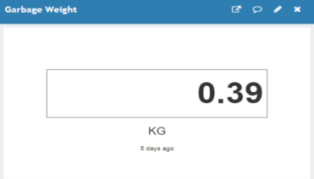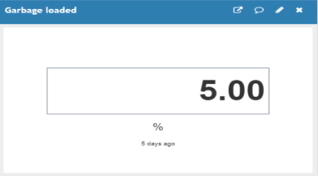

**Fig-7**: Garbage-loaded percentage **Fig-8:** Garbage-loaded weight

In this section, we do testing on hardware and software. After that, we added test results on how the smart dustbin reacts with the garbage. The testing procedure was also added to remember the steps of how it works. Lastly, the think speak gives us the real situation of a smart dustbin that we build.

IoT-based trash cans help people dispose of their waste It’s easy and helps reduce phone calls and waiting work Designated area cleaners and A healthier environment to live in, you are nothing. Diseases and people become healthier and less vulnerable to Diseases caused by these waste products. This system Ensures trash cans are cleaned as soon as they reach the trash level reach the maximum. It takes over power with the help of a battery. If you don’t clean the trash can within a certain amount of time, For appropriate action to be taken, recordings might be transmitted to a sweeper or higher authority for affected contractors. Finally, keeping the environment clean and Waste management becomes much easier. From an environmental point of view, it contributes to green and hygiene, from a business point of view, we try to originate it reasonably for as most of people as possible.

**3. CONCLUSIONS**

As a result of this project, the suggested system would have the ability to oversee the administration of the entire collection process as well as monitor the solid waste collecting process. Instead of sorting the trash by hand as in the past, this initiative is incredibly successful at controlling waste in any large city. The problems with garbage overflow will be fixed with the aid of this project, making the area tidy, clean, and hygienic. The most effective method for gathering and sorting the trash is the one that has been suggested. The collection of solid garbage has been rather stagnant in recent years. To address this, we have suggested a waste management method that is more effective. The automated separation of moist and dry waste is beneficial in determining the garbage's economic worth.

**4. REFERENCES**

1. Chavan, S., Patil, U., Koshy, S. S., & Srikanth, S. V. (2021, March). Garbage zero (Garb0): An IoT framework for effective garbage management in smart cities. In *2021 International Conference on Artificial Intelligence and Smart Systems (ICAIS)* (pp. 1336-1342). IEEE.
2. Vijay, S., Kumar, P. N., Raju, S., & Vivekanandan, S. (2019). Smart waste management system using ARDUINO. *International Journal of Engineering Research & Technology (IJERT)*, *8*(11).
3. Badve, M., Chaudhari, A., Davda, P., Bagaria, V., & Kalbande, D. (2020, October). Garbage collection system using iot for smart city. In *2020 Fourth International Conference on I-SMAC (IoT in Social, Mobile, Analytics and Cloud)(I-SMAC)* (pp. 138-143). IEEE.
4. Chaudhari, S. S., & Bhole, V. Y. (2018, January). Solid waste collection as a service using IoT-solution for smart cities. In *2018 International conference on smart city and emerging technology (ICSCET)* (pp. 1-5). IEEE.
5. Chaudhari, M. S., Patil, B., & Raut, V. (2019, March). Iot based waste collection management system for smart cities: An overview. In *2019 3rd International Conference on Computing Methodologies and Communication (ICCMC)* (pp. 802-805). IEEE.
6. Lokuliyana, S., Jayakody, A., Dabarera, G. S. B., Ranaweera, R. K. R., Perera, P. G. D. M., & Panangala, P. A. D. V. R. (2018, August). Location based garbage management system with iot for smart city. In *2018 13th International Conference on Computer Science & Education (ICCSE)* (pp. 1-5). IEEE.
7. (2023). SMART WASTE MANAGEMENT SYSTEM BASED ON THE INTERNET OF THINGS. International Research Journal of Modernization in Engineering Technology and Science.
8. Fazio, M., Paone, M., Puliafito, A., & Villari, M. (2012, July). Heterogeneous sensors become homogeneous things in smart cities. In *2012 Sixth International Conference on Innovative Mobile and Internet Services in Ubiquitous Computing* (pp. 775-780). IEEE.
9. Balakrishna, C. (2012, September). Enabling technologies for smart city services and applications. In *2012 sixth international conference on next generation mobile applications, services and technologies* (pp. 223-227). IEEE.
10. Suakanto, S., Supangkat, S. H., & Saragih, R. (2013, June). Smart city dashboard for integrating various data of sensor networks. In *International Conference on ICT for Smart Society* (pp. 1-5). IEEE.
11. Carli, R., Dotoli, M., Pellegrino, R., & Ranieri, L. (2013, October). Measuring and managing the smartness of cities: A framework for classifying performance indicators. In *2013 IEEE international conference on systems, man, and cybernetics* (pp. 1288-1293). IEEE.
12. Tao, C., & Xiang, L. (2010, November). Municipal solid waste recycle management information platform based on internet of things technology. In *2010 International Conference on Multimedia Information Networking and Security* (pp. 729-732). IEEE.
13. Anghinolfi, D., Paolucci, M., Robba, M., & Taramasso, A. C. (2013). A dynamic optimization model for solid waste recycling. *Waste management*, *33*(2), 287-296.
14. Maher, A., Hannan, M. A., Hassan, B., Begum, R. A., & Huda, A. (2010, June). Solid waste monitoring system integration based on RFID, GPS and camera. In *The world congress on engineering* (pp. 2078-0966).
15. Rajput, S. K., & Patil, M. Waste Management in IoT-Facilitated Smart Cities-A Suvery. *International Journal of Computer Applications*, *975*, 8887.
16. Vicentini, F., Giusti, A., Rovetta, A., Fan, X., He, Q., Zhu, M., & Liu, B. (2009). Sensorized waste collection container for content estimation and collection optimization. *Waste management*, *29*(5), 1467-1472.
17. Chaudhari, S. S., & Bhole, V. Y. (2018, January). Solid waste collection as a service using IoT-solution for smart cities. In *2018 International conference on smart city and emerging technology (ICSCET)* (pp. 1-5). IEEE.
18. Lokuliyana, S., Jayakody, A., Dabarera, G. S. B., Ranaweera, R. K. R., Perera, P. G. D. M., & Panangala, P. A. D. V. R. (2018, August). Location based garbage management system with iot for smart city. In *2018 13th International Conference on Computer Science & Education (ICCSE)* (pp. 1-5). IEEE.
19. Chowdhury, P., Sen, R., Ray, D., Roy, P., & Sarkar, S. (2018, August). Garbage monitoring and disposal system for smart city using IoT. In *2018 Second International Conference on Green Computing and Internet of Things (ICGCIoT)* (pp. 455-460). IEEE.
20. Fooladi, S., Fazlollahtabar, H., & Mahdavi, I. (2015). Waste collection vehicle routing problem considering similarity pattern of trashcan and garbage unloading.
21. Anagnostopoulos, T., Zaslavsky, A., & Medvedev, A. (2015, April). Robust waste collection exploiting cost efficiency of IoT potentiality in Smart Cities. In *2015 International conference on recent advances in internet of things (RIoT)* (pp. 1-6). IEEE.
22. Mirchandani, S., Wadhwa, S., Wadhwa, P., & Joseph, R. (2017, December). IoT enabled dustbins. In *2017 International conference on big data, IoT and data science (BID)* (pp. 73-76). IEEE.
23. Priano, F. H., & Guerra, C. F. (2016, September). Fully smart cities: Analysis of the city to Smart City transformation process. In *2016 IEEE International Smart Cities Conference (ISC2)* (pp. 1-8). IEEE.
24. Suakanto, S., Supangkat, S. H., & Saragih, R. (2013, June). Smart city dashboard for integrating various data of sensor networks. In *International Conference on ICT for Smart Society* (pp. 1-5). IEEE.
25. Lokuliyana, S., Jayakody, A., Dabarera, G. S. B., Ranaweera, R. K. R., Perera, P. G. D. M., & Panangala, P. A. D. V. R. (2018, August). Location based garbage management system with iot for smart city. In *2018 13th International Conference on Computer Science & Education (ICCSE)* (pp. 1-5). IEEE.

**BIOGRAPHIES of AUTHORS**

|  |  |
| --- | --- |
|  | **Md Rashed** is currently a bachelor's student in the Department of Information and Communication Engineering (ICE) at Pabna University of Science and Technology (PUST), Bangladesh. His research interests include Deep learning, IoT, Robotics, Biomedical Signal and Image Processin. He can be contacted at email: [rashedulislam200613@gmail.com](mailto:rashedulislam200613@gmail.com)  Shoaib Ahmad, a bachelor's student studying Information and Communication Engineering (ICE) at Pabna University of Science and Technology. His research interests include IoT, Machine Learning, Deep Learning, and NLP. He can be contacted at email: [shoaibahmadsakib@gmail.com](mailto:shoaibahmadsakib@gmail.com)  Md Shakil Hossain is a bachelor's student studying Information and Communication Engineering (ICE) at Pabna University of Science and Technology (PUST) in Bangladesh. My Research interests include IoT, Artificial intelligent and Robotics .Currently ,He can be contacted at email: shakil.200636@s.pust.ac.bd |
|  |  |
|  |  |